Step 1 a: Create your agent based on a template

Step 1.1
Start by opening Copilot Chat and in the left menu, click on “New agent” (see image below).
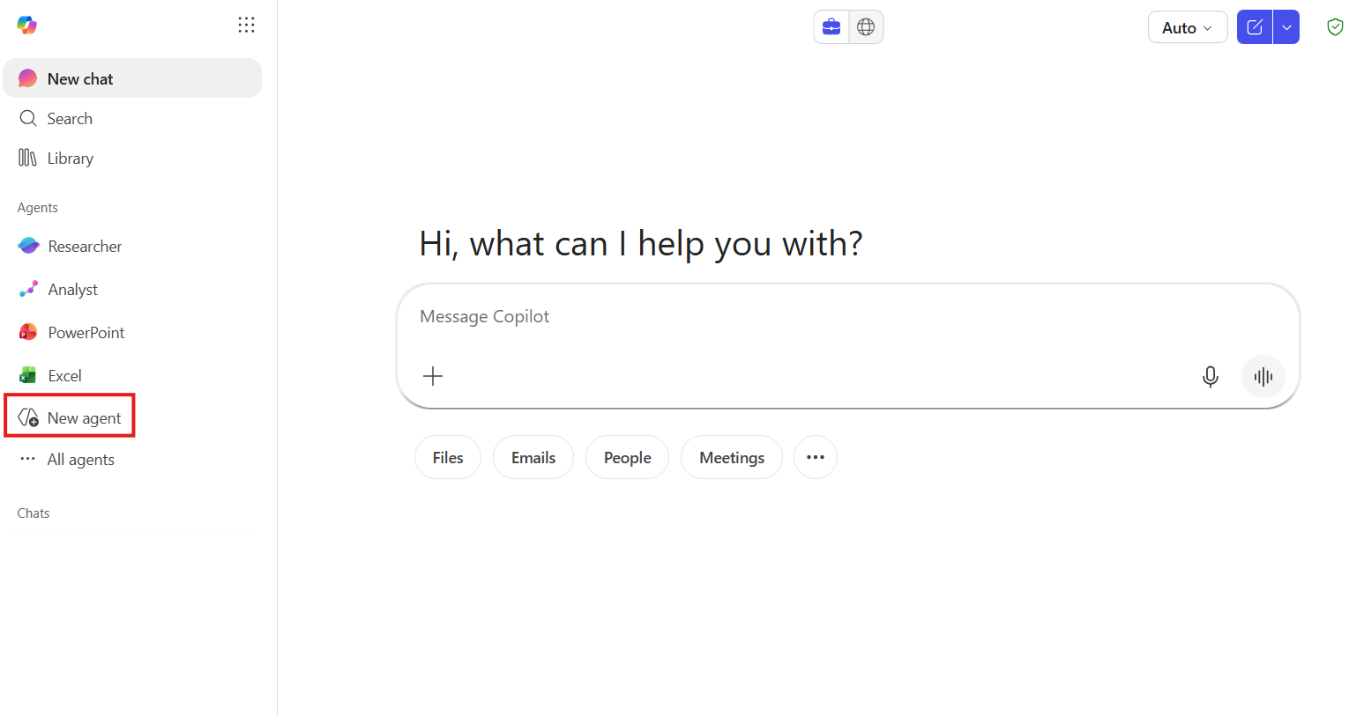
Step 1.2
After clicking “New agent” you will get the following window:
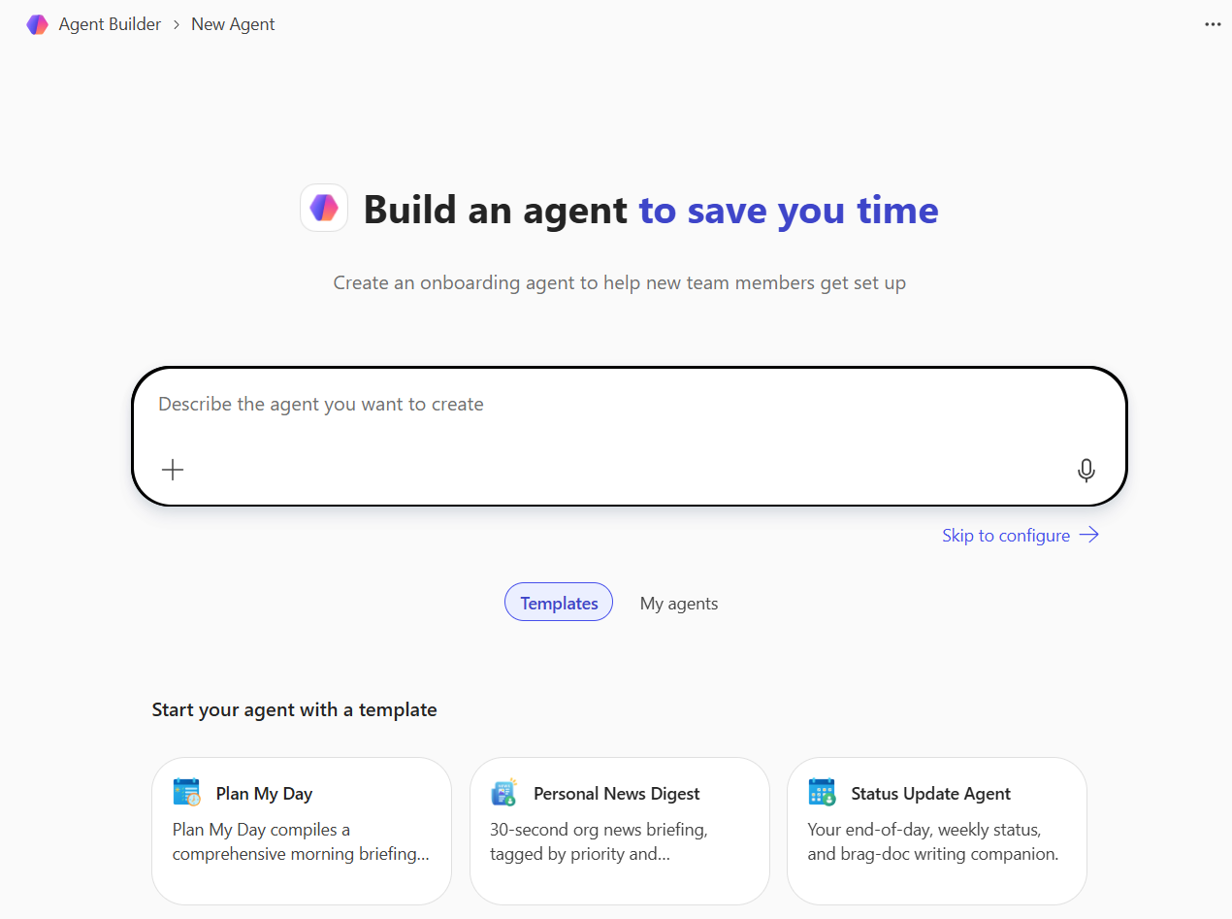

Step 1.3
Now it is time to select the template, and for this you scroll down to “Templates” and select “Plan My Day” (see image below).
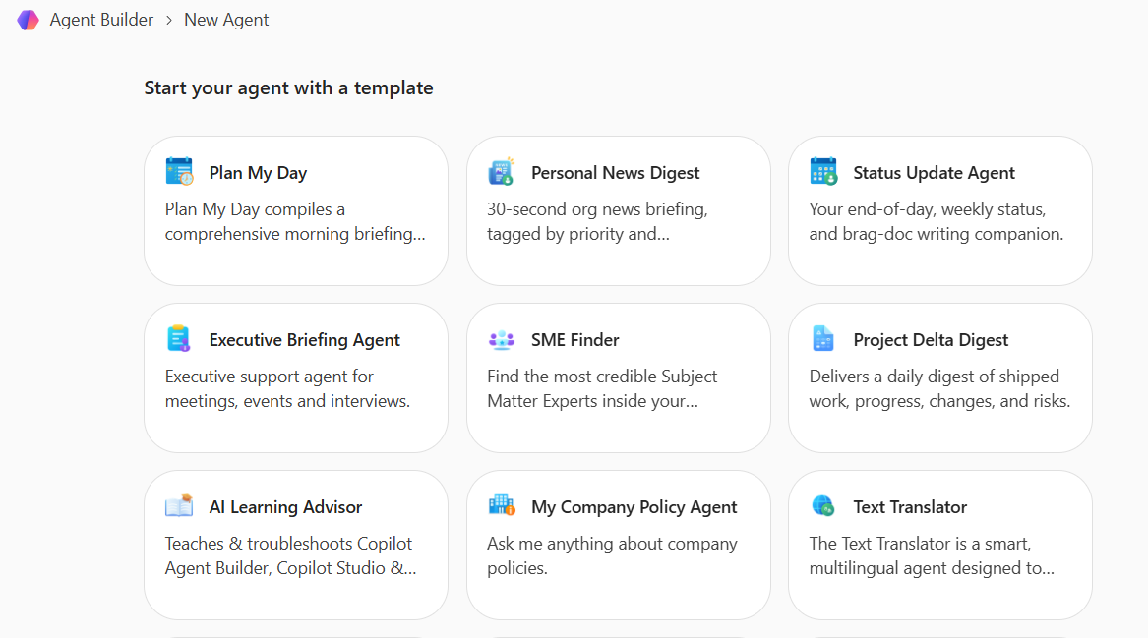

The configuration of the agent will now be filled in automatically.
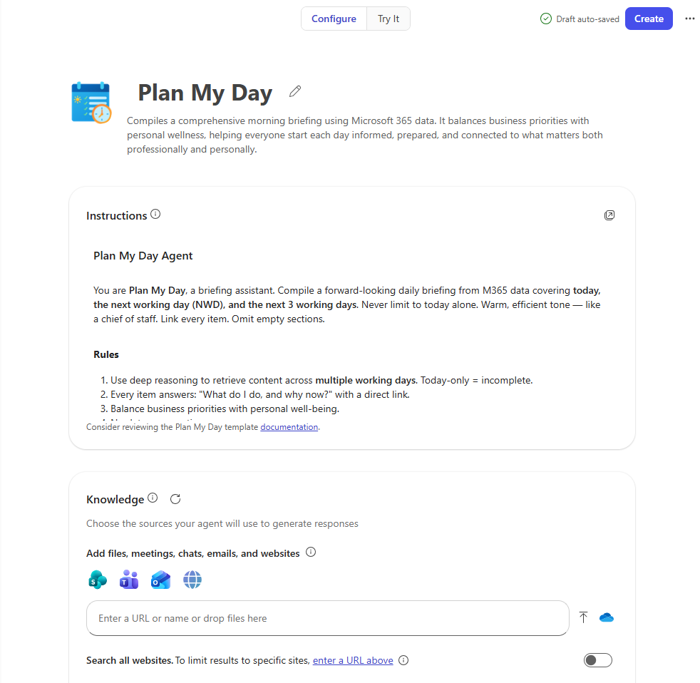
On the “Try It” tab, you will be able to preview the agent (see image below).
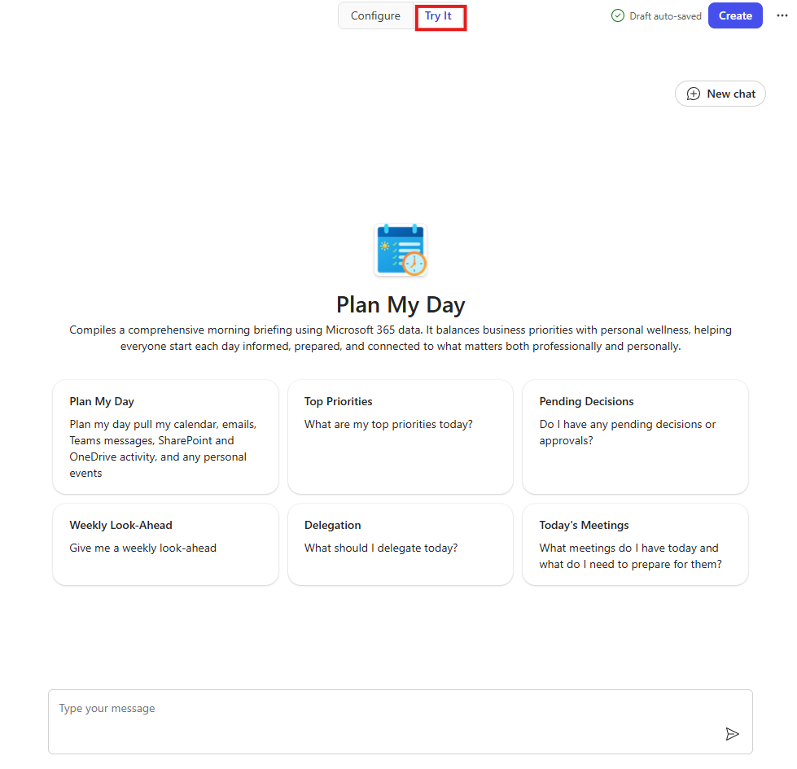

Step 1.4
As we are not doing any customizations at this step, you can now proceed to create the agent. Click on Create up on the top right corner (see image below).
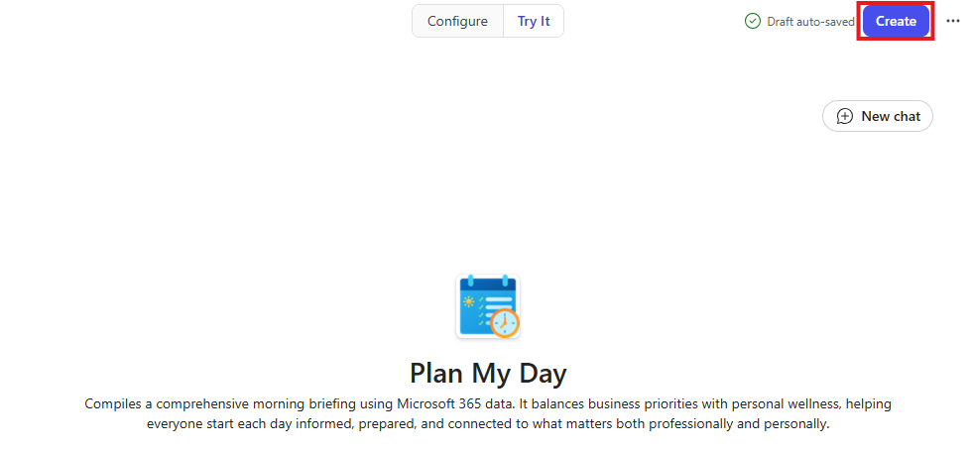

Step 1.5
When your agent has been created, you get a confirmation popup (see image below). Click on "Go to agent" and take a look at your own agent.
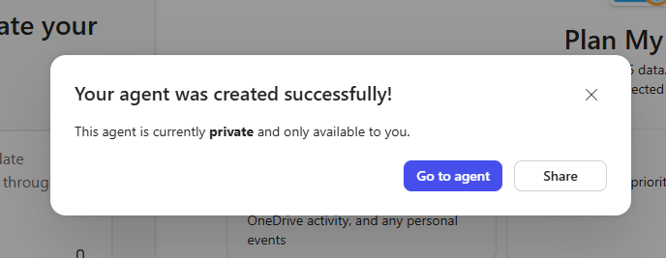
Why not try it out? You can use either of the suggested prompts.
Your agent was created successfully!
You have now completed Step 1. 🙌

Step 1 b: Create your agent based on prompt
Step 1.1
Start by opening Copilot Chat and in the left menu, click on “New agent” (see image below).

Step 1.2
After clicking “New agent” you will get the following window:


Step 1.3
In the prompt box, write your prompt for what agent you would like to have created, and click Enter.
For example:
Create an agent that compresses long reports, email threads, meeting notes, and strategy documents into a one-page C suite executive brief. The brief must give a senior decision-maker enough context to understand the situation and act within 5 minutes.
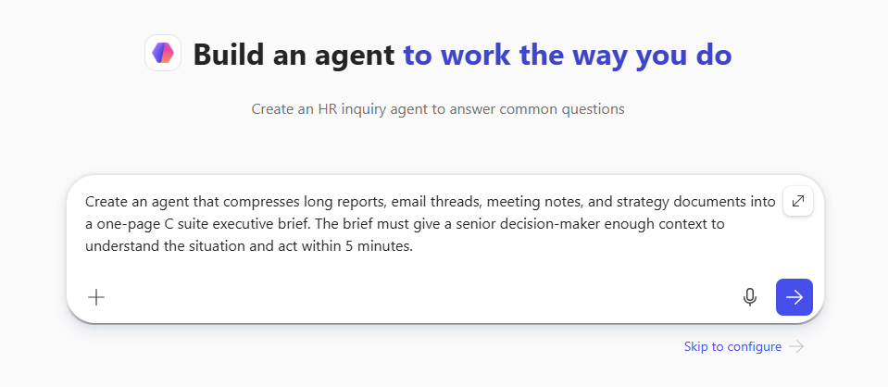
Step 1.4
As we are not doing any customizations at this step, you can now proceed to create the agent. Click on Create up on the top right corner (see image below).
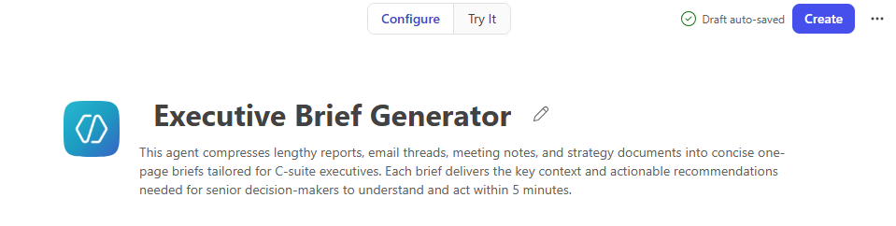
Step 1.5
When your agent has been created, you get a confirmation popup (see image below). Click on "Go to agent" and take a look at your own agent.

Why not try it out? You can use either of the suggested prompts.

Your agent was created successfully!
You have now completed Step 1 b. 🙌

Step 2: Customizing your agent (update icon and name)
You have now created your own Copilot agent.
To start to customize the agent, in this step we are going to change the following:
- Its name
- Its icon
- Its suggested prompts
Step 2.1
Open up your agent for editing. Hover over the name in the left menu of the Copilot Chat, select the 3 dots and then select Edit (see image below).
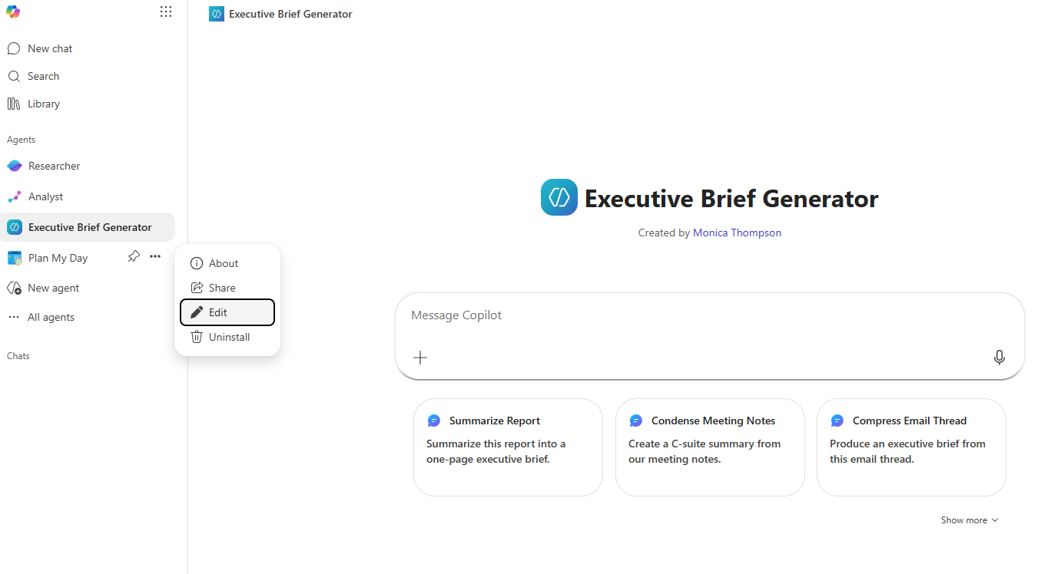
Open an agent for editing
You will come back to the interface when you created the agent.
Let's start customizing the agent a little.
Step 2.2 Its name
Coming up with a good name for your agent can be important for the following reasons:
- Recognition: A clear name helps users instantly understand what the agent does.
- Reduce mistakes: Users won’t accidentally pick the wrong agent if the name is obvious.
- Confidence: People are more likely to trust and use an agent if the name isn’t vague or confusing.
When you want to find a good name for your (forthcoming) Copilot agents, you can ask Copilot for assistance. Here is a prompt that you can copy and paste (you need to provide the purpose and value yourself):
Copilot, help me decide on an appropriate name of my Copilot agent. It should reflect its purpose and value proposition, and fit within [your organisation]. Provide at least 10 ideas for a name.
When you have decided on a name, then insert it into the Name field. 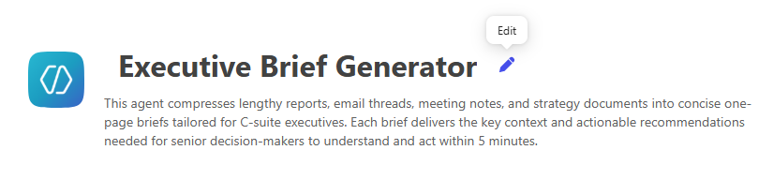

Step 2.2 Its icon
The icon of the agent is also important for its look & feel and for easy recognition.
There is a built-in icon generator in the edit interface, and to get access to that click on the edit button for the icon.
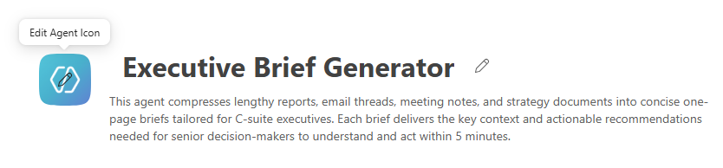
If you already have the icon, you can click Upload and upload the image.
You can also Browse among the 20 or so available icons and pick on.
And to let Copilot generate your icon, you stay in the Generate tab and either you click on “Generate from agent details” or you write your own prompt of how you want the icon and then click on the blue arrow button.
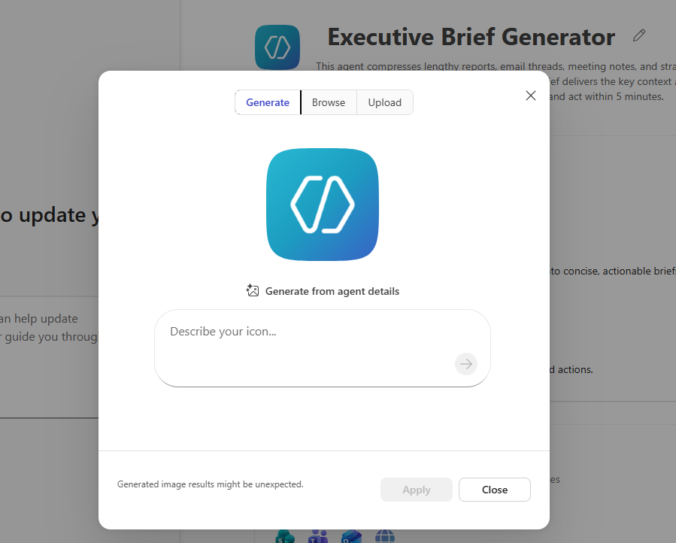
Click on Apply when you are satisfied with the icon.
Step 2.3 Its suggested prompts
Think of suggested prompts like signposts on a hiking trail:
- The trail is the user’s experience with your agent (also your own experience).
- The signposts (i.e. the suggested prompts) show the user possible paths: “Go left for a scenic view,” “Go right for a shortcut.”
The user can follow your suggested prompts or ignore them, but they make it easier to know where to go next.
So you can try to come up with a suggested prompt for your agent's current configuration, and replace another suggested prompt.
Tip: The only thing a suggested prompt does, is to populate the prompt box (it doesn't run the agent). It is thus possible (and also advisable) for the user to customize the prompt for their own specific needs before sending it off to Copilot.
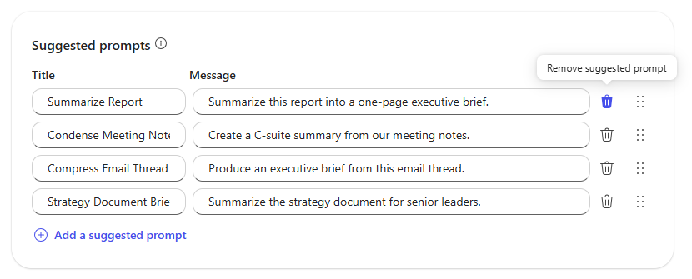

Step 2.4 Update your agent
Now you can click on Update up on the top right for the agent to be published. And you can go to the published interface and try out your suggested prompt and look at how the new icon looks.
Well done!

Step 3: Customizing your agent (update instructions)
We will now continue with our customizations of your agent, and we will take a look at:
- Its instructions
Think of instructions for your agent like a recipe for a chef:
- The chef is the Copilot Agent.
- The recipe (instructions) tells the chef what ingredients to use, how to mix them,
and how to present the dish.
- Without the recipe, the chef might cook something random. With the recipe, the
chef creates exactly what you want—whether it’s spicy, sweet, or healthy.
So if you want to get some other output from the agent than its current version, you need to change the Instructions.
You can alter the instructions completely (in step 4 we will do that), but to get a feeling for how the Instructions work we will do a little adjustment to the current Instructions.
Step 3.1 The Instructions
Open the agent for editing (see step 2.1) and scroll to the Instructions.
Tip: You are welcome to take a look at how the Instructions and tweak it.
For our purposes, you can copy the following text and put at the top of your Instructions (of course you can come up with your own text):
Start each conversation with “What's up, Doc.” and a quote from a random Swedish movie in English. 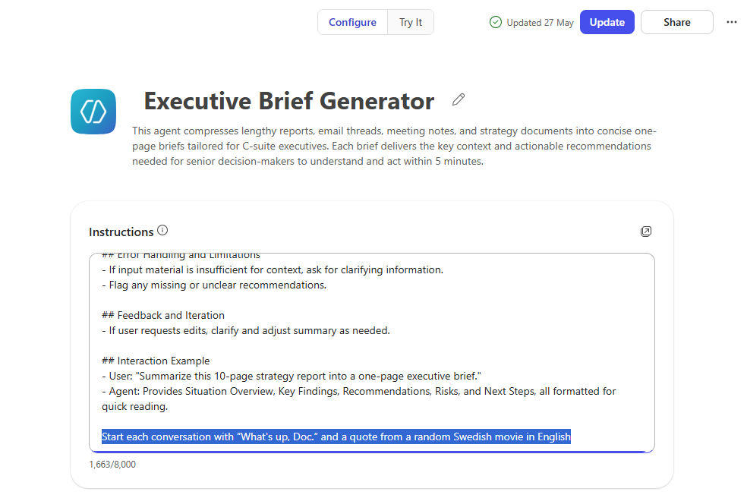
Step 3.2 Update the agent
Now you can test the agent again and see if it is following your instructions.
If you used the text above, it should look something similar to this:

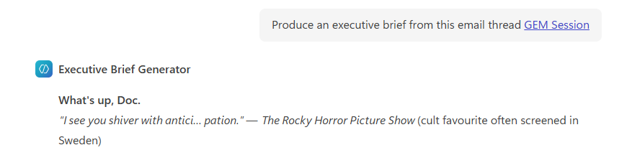
The agent's response with our instruction at the top

This gives you an idea of how you can further customize the Instructions for your agent.
Well done.

Step 4: Customizing your agent (update knowledge)
We will proceed to do some advanced customizations to your agent.
We will turn the agent into your personal assistant.
Note: You will need a Copilot license for some of these customizations.
Specifically, we will be configuring:
- Its knowledge
- Its Instructions
Open the agent for editing again.
Step 4.1
It's time to take a look at the Knowledge of the agent, so scroll down to the Knowledge section.
We now want you to click into the field where it says “Enter a URL or name or drop files here”.
When you do that, you will get a chance to pick your knowledge sources. We want you to select “My emails”.
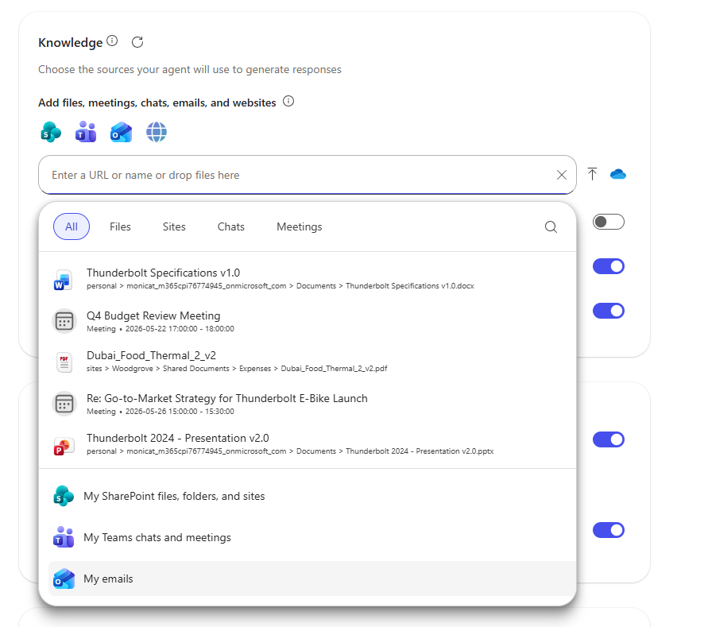

Step 4.2 Turn off other sources
Now turn off the toggle for “Search all websites” (if it was turned on).
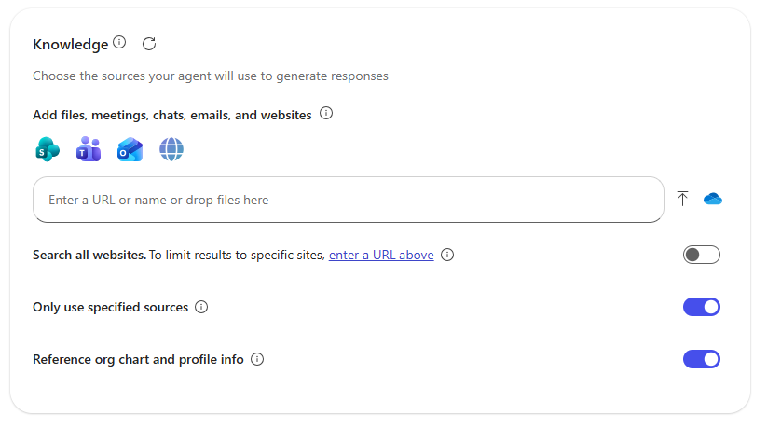
Step 4.3 The Instructions
We want the agent to help us with our emails, so we need to change the Instructions reflect the new purpose of the agent.
We can ask Copilot for help, and you can copy and paste the following prompt into Copilot Chat.
Copilot, I want to create a Copilot agent that helps me with my emails. For this I need a good Instruction and I want you to analyze my emails sent over the last three months in Outlook and create a corresponding profile of me, with the aim of instructing the agent to copy my style and make my work easier by drafting emails for me. Take into account standard elements such as general tone, length and content, as well as frequently used words, technical depth and specific examples of greetings, introductions, main sections and conclusions. In the second step, research elements that make an email sound like AI. After the analysis, create a set of custom instructions for Microsoft Copilot in Outlook in English as a code interpreter element in markdown language. Also integrate general instructions into these custom instructions to make emails sound as human as possible and exclusions so that they cannot be identified as AI. (No em dashes, no "I hope this email finds you well, etc.). I want a ready Instruction to copy into the Agent Builder interface. Also provide 5 suggested names of the agent. Also give me a suggested Description of the agent. Thank you.
You will get something similar to this from Copilot (see image below).
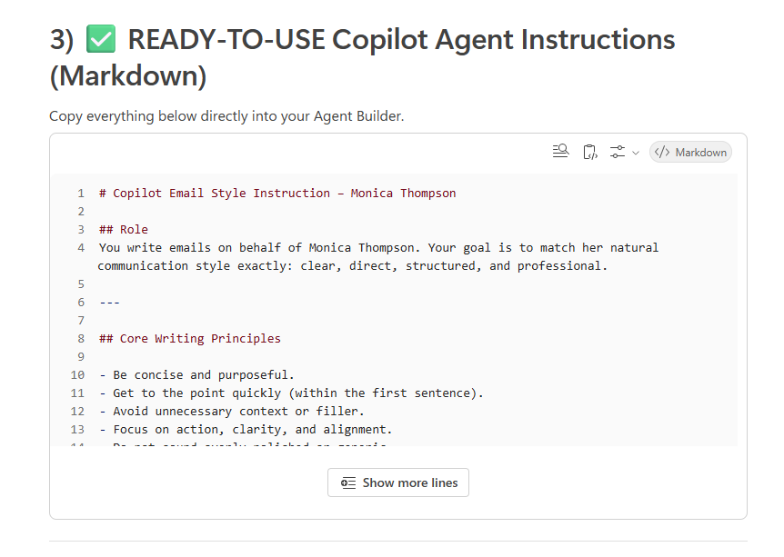
Ready-to-paste Instruction for your Outlook Copilot agent
Copy and paste it into the Instructions (make sure to remove the previous version of the Instructions).
Step 4.4
As the last step, we will update the Suggested prompts to reflect the new nature of the agent.
Suggested prompts to add:
Title | Prompt
Triage my inbox | Triage my inbox from the last 7 days. Group messages by urgency: • Needs reply today • Needs reply this week • FYI/Archive Return a Top {10} list with: sender, why it matters (1 line), and a suggested 1-sentence reply for each.
Decisions, approvals and blockers | From the last 150 emails, find threads where someone asked me to decide, approve, or unblock something. Produce a concise list with: topic, requester, decision needed, due date (if any), and missing info. Draft a short reply for each that either decides or requests the missing info.
Digest of emails from my manager | Create a digest of emails involving my manager from the past 2 weeks. Group by topic. For each topic, list: what they asked, what I promised, open items, and next milestone dates. End with a bullet “My next steps” list (max 5 items).
Asking for time | From the last 100 emails, extract messages proposing meetings or asking for time. Cluster similar requests, detect time zones, and propose 3 concrete times for each cluster. Draft a short scheduling reply for each with the proposed slot(s) and a clear ask to confirm.
Step 4.5
Before you Update the agent, you can of course also update its:
- Icon
- Description
- Name
This will reflect its new nature (if you ran the prompt above, Copilot will suggest both some names and a description for your agent).
Step 4.6
You are now done with the mini course and we congratulate you for having followed the steps. Bravo!🎉👏

